Nexora imports exports and migration
Document 18 of the Nexora learning guides
Source snapshot 14 October 2026 at 06:41 UTC
Understand data previews, commit steps, export paths and the difference between importing data and database migrations.

Recognise the screen and its scope
Open /work/imports, /relationships/contacts, /insights. CRM routes use port 3017; member routes use 3018; public website routes can use 3019. Brackets name a route parameter, not text to paste into a browser. Choose a real record or site id from the application.
This guide covers Task JSON import preview and commit; CRM CSV import and export; Report and finance exports; Migration workbook field mapping; EF database migrations; Error review and reconciliation.
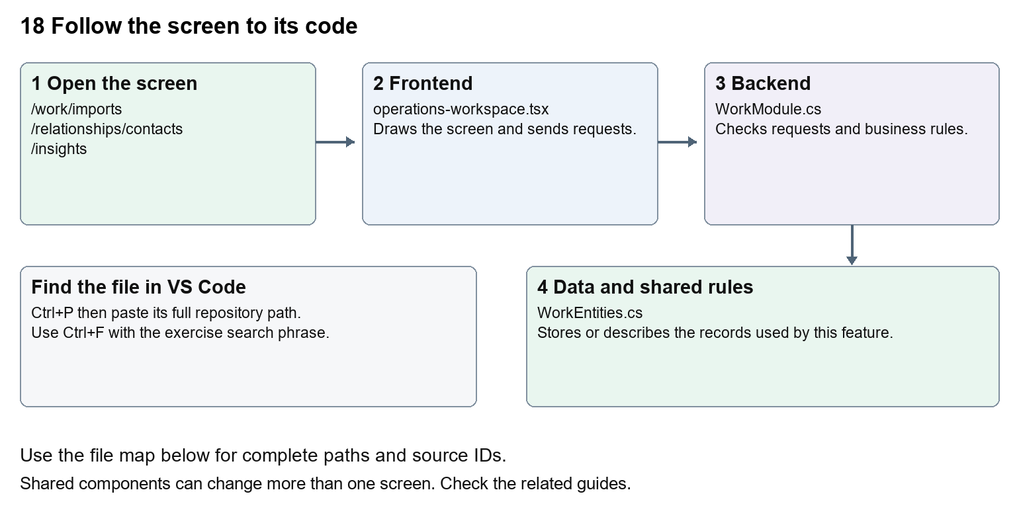
The diagram shows the file roles. The full paths below are what you paste into Ctrl+P.

Find the files in VS Code
Role | File and source ID | What it does
Screen | S0118 operations-workspace.tsx | Main UI or route for this topic
Server | S0539 WorkModule.cs | Endpoints or server rules
Data | S0521 WorkEntities.cs | Data shape or persistence structure

Screen S0118
apps/web/src/features/operations/operations-workspace.tsx
Server S0539
backend/src/Modules/Nexora.Modules.Work/WorkModule.cs
Data S0521
backend/src/Modules/Nexora.Modules.Work/Domain/WorkEntities.cs
The complete HTML manual opens these source IDs inside its Source library. The Word manual shows short labelled extracts so you can learn the flow before reading large files. Each individual Markdown guide includes its complete primary files after the walkthrough.

Follow the request and the records
1. A data import first parses rows into a request.
2. Preview validates rows and records errors without the final business write.
3. An authorised commit applies a validated import using its version.
4. Exports return the permitted matching records.
5. Database migrations separately change table structure, not business import row mapping.

Read the code with an explanation
A workbook field inventory is a mapping aid, not a universal working importer. The Work screen specifically accepts up to 500 task rows as JSON. CRM has its own import endpoints and schema. EF migration files change the SQL table design and are normally generated from model changes. Never treat a successful preview as proof a full migration reconciled correctly.
Source reference S0118 apps/web/src/features/operations/operations-workspace.tsx
Selected opening lines with their original numbers. The complete file is in the HTML source library.
0001 "use client";
0002 import listingStyles from "../crm/record-listing.module.css";
0003 import { WorkspaceHeading } from "@/components/ui/workspace-heading";
0004 import { RecordListing, useRecordPage } from "../shared/record-listing";
0005 import { Plus, ArrowLeft } from "lucide-react";
0006 import { useEntityListing } from "../shared/entity-listing-controls";

The import lines lead to shared components and helpers. Start at the exported component or route function; follow the request helper to the server rather than assuming the whole feature lives in this file.
Source reference S0539 backend/src/Modules/Nexora.Modules.Work/WorkModule.cs
Extract from source line 25. A fragment from a long line is shown without the rest of that line.
0025 ork.manage", typeof(WorkItem));api.MapGet("/directory",(IIdentityDirectory directory,C

On the server, look for MapGet to load records, MapPost to create or perform an action, MapPut or MapPatch to change data, and RequireAuthorization for permissions. Some shared methods register endpoints indirectly. Find SaveChangesAsync to see the database write. A request method alone does not tell you every side effect.
Source reference S0521 backend/src/Modules/Nexora.Modules.Work/Domain/WorkEntities.cs
Selected opening lines with their original numbers. The complete file is in the HTML source library.
0001 using Nexora.BuildingBlocks.Domain;
0002 namespace Nexora.Modules.Work.Domain;

Follow model fields to their request names and database mapping. An id points to a particular record. A tenant id limits the organisation. A version or concurrency stamp protects newer edits. Some model files describe contracts rather than tables; check the owning DbContext before assuming storage.

Make or trace your first change
1. Press Ctrl+P and open apps/web/src/features/operations/operations-workspace.tsx.
2. Press Ctrl+F and search for Validate and preview. In this snapshot it appears at line 31.
3. Replace only the task import button label. Open /work/imports in create mode and inspect the form. Do not click Commit validated import or run a database migration for this text exercise.
4. Replace only Validate and preview with Check rows and preview in that intended location. Keep quotes, tags, JSON keys and routes intact.
5. Save with Ctrl+S. Inspect Problems and the local screen. Review the diff and restore the original text when you finish practising.
Extract from source line 31. A fragment from a long line is shown without the rest of that line.
0031 ed={busy} className={primaryClass}>Validate and preview</button></form></Panel>}

These exercises have not been applied to the application. Their search phrases are verified against the captured source. Line numbers can move; the phrase and file path are your main navigation aids.

Check a change and diagnose problems
Confirm the original screen still loads, the changed words appear in the intended place, and another screen using the same component still behaves correctly. If an action fails, inspect the browser Network response, the relevant helper and server validation message. Use the common error table at the beginning of the manual. Reload on a version conflict instead of removing the version check.
A syntax error after a text edit usually means a quote, brace or closing tag changed. Compare your diff with the original. An unchanged browser result can mean the wrong port, a saved published configuration overriding a default, or a running API that has not reloaded.

Understand the current limits
Preview, commit and reconciliation are distinct evidence. A complete customer migration still needs source-specific mapping, counts, error review and acceptance. A schema change needs a reviewed migration for the appropriate context.

Continue learning
Related guides 05 Nexora CRM contacts, 17 Nexora tasks and notifications, 19 Nexora insights and reporting, 30 Nexora backend database and maintenance.

